INTRO TO LINUX - Challenges:
- Download the GZIP file, decompress it and find the size (in bytes) of the file.
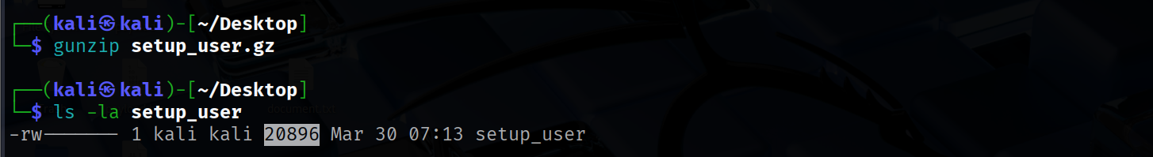
20896
- Investigate the file and find the type of the file.
ELF *
- Give execute permissions to the file and then execute it with root permissions. Navigate to the /home directory and find which user has been created?
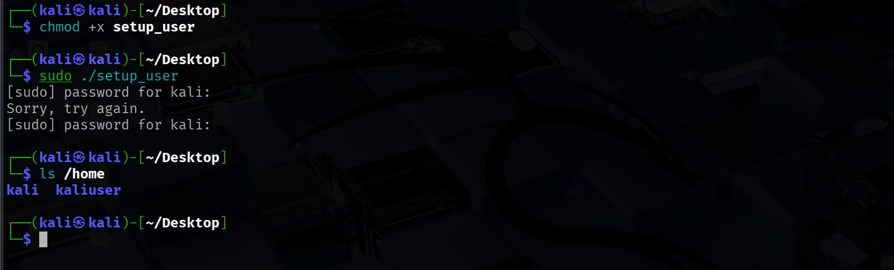
kaliuser
- switch to the created user using the password "kali1234" and Navigate to the Notes folder. There is a file inside it, open it and find its content.
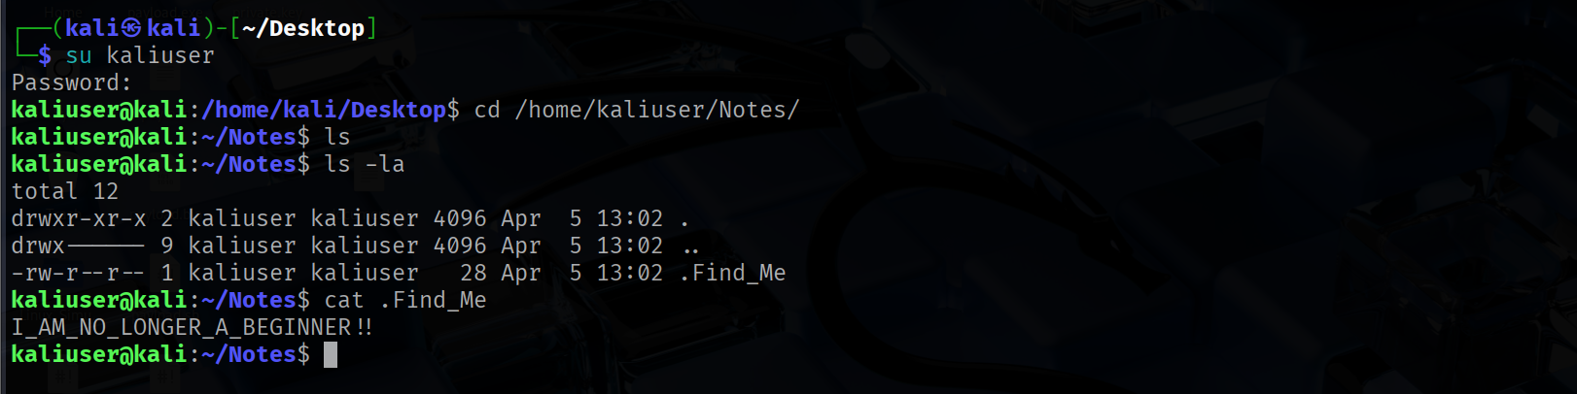
I_AM_NO_LONGER_A_BEGINNER!!

